Supply Chain Management (SCM) — NPTEL
Week 8 · Session 4: SC Network Design — Heuristic Approaches (H1 & H2)
1. Week 8 Recap
Session | Topic | Method
W8 S1 | Facility Selection | Break-Even Analysis
W8 S2 | Facility Location | Centre of Gravity + Excel Solver (GRG Nonlinear)
W8 S3 | Demand Allocation + CPLP | LP Formulation + Solver (Simplex LP / Binary)
W8 S4 ← | SC Network Design | Heuristic Approaches (H1 & H2)

★ This session: SC Network Design — 2-tier network (Mfr → WH → Retailer). Solved via heuristics. Optimal solution (LP) comes in next session.

2. Case — SC Network Design Problem
Network Structure
Node | Name | Count | Key Data
Manufacturer | M1, M2 | 2 | M1: 1,50,000 units | M2: 1,20,000 units
Warehouse | W1, W2, W3 | 3 | Same handling cost (assumed)
Retailer | R1, R2, R3, R4 | 4 | 45K | 35K | 68K | 70K units
Product | Single product | 1 | Same production cost across M1, M2 (assumed)
Taken from: Designing and managing the supply chain, Simchi-Levi, D. Kaminsky, Shankar R (2022)
Key Assumptions
- Production cost: same for both M1 and M2 — not a differentiating factor
- Handling cost: same for all 3 warehouses — simplified for the problem
- In real SC, these costs vary across facilities

Transportation Cost Matrix (₹ per unit)
- Per unit shipment cost is given for every Manufacturer → Warehouse and Warehouse → Retailer pair
- W1 has the lowest cost to all 4 retailers — highlighted in the matrix below
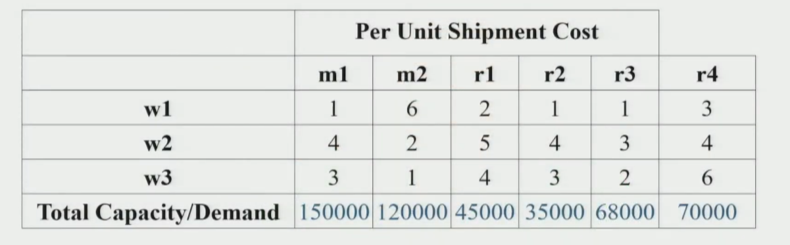

M → W | W1 | W2 | W3 | Capacity
M1 | 1 | 2 | 3 | 1,50,000
M2 | 3 | 2 | 1 | 1,20,000
W → R | R1 | R2 | R3 | R4
W1 | 2 | 1 | 3 | 4 | ← lowest
W2 | 5 | 4 | 6 | 3
W3 | 4 | 3 | 5 | 6
Demand | 45,000 | 35,000 | 68,000 | 70,000 | Total: 2,18,000
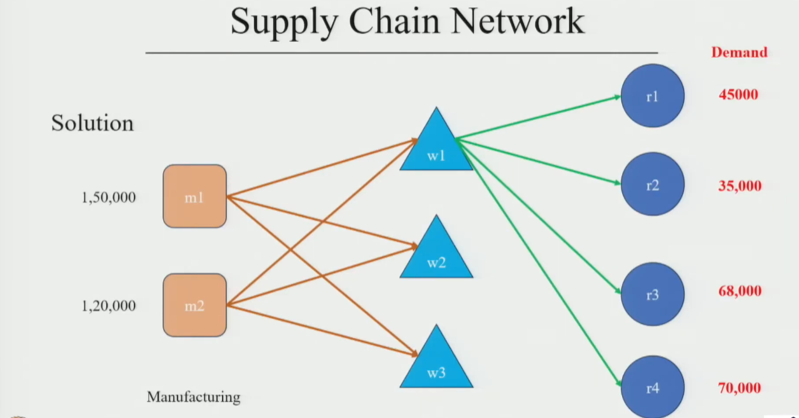
Objective
- Find the optimal distribution strategy — which manufacturer supplies which warehouse, and which warehouse serves which retailer
- Subject to: supply constraints (manufacturer capacity) and demand constraints (retailer demand fully met)
- Goal: minimize total distribution cost

3. What is a Heuristic?
- A rule-based, practical approach to find a good (not necessarily optimal) solution
- Faster and simpler than full LP optimization
- Different heuristics can give different costs for the same problem
- Useful as a starting point — actual optimum found via LP/Solver

★ Heuristic = good solution quickly. LP = best solution (but more effort). Always compare both.

4. Heuristic 1 — Cheapest Warehouse First
Logic
- Step 1: Pick the warehouse with lowest total shipping cost to all retailers
- Step 2: Route all retailer demand through that warehouse
- Step 3: Pick the cheapest manufacturer to supply that warehouse — exhaust its capacity first
- Step 4: Fulfill remaining demand from the next manufacturer
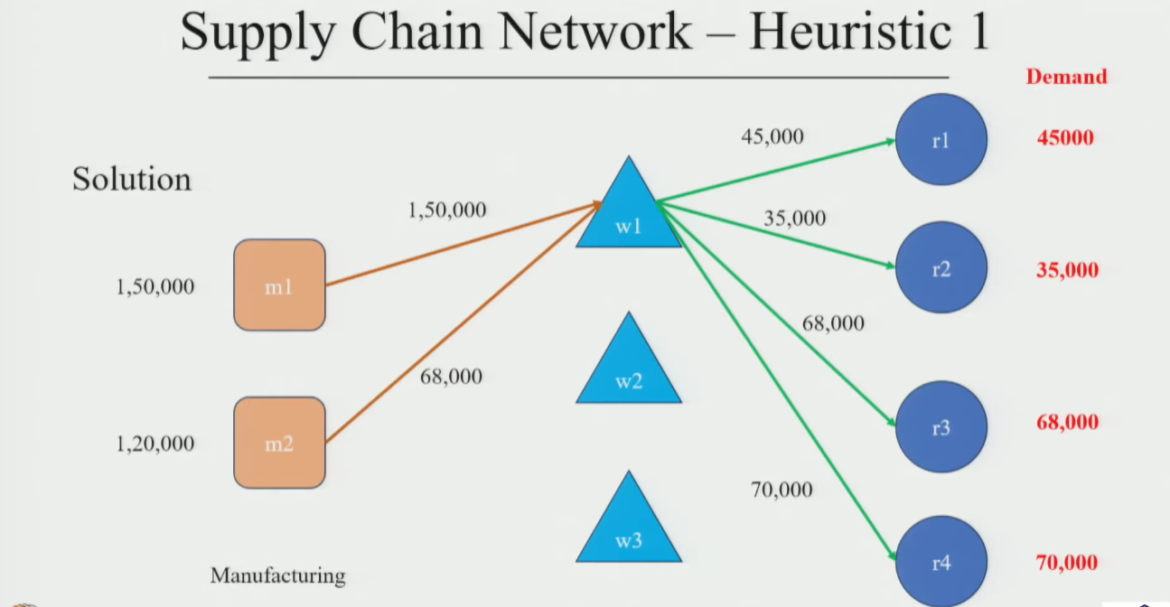
Applying to the Case
- Compare total W→R cost for W1, W2, W3:
- W1 → lowest cost to R1, R2, R3, R4 → W1 selected
- Total demand = 45K + 35K + 68K + 70K = 2,18,000 units
- M1 (cheaper to W1) supplies first → exhausts 1,50,000 units:
- R1: 45,000 ✓ R2: 35,000 ✓ R3: 68,000 ✓ Subtotal: 1,48,000
- Remaining capacity of M1: 2,000 units → supplied to R4 (last because cost is highest)
- Remaining R4 demand: 70,000 − 2,000 = 68,000 units → supplied from M2
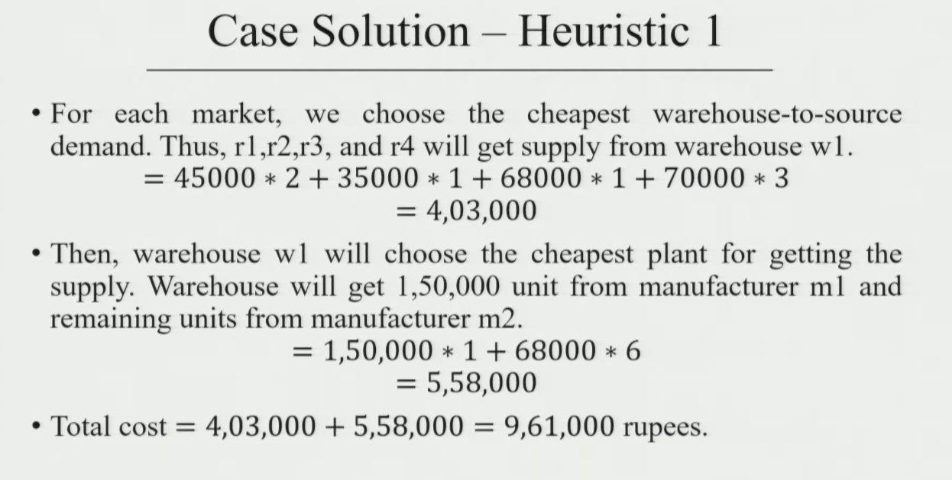
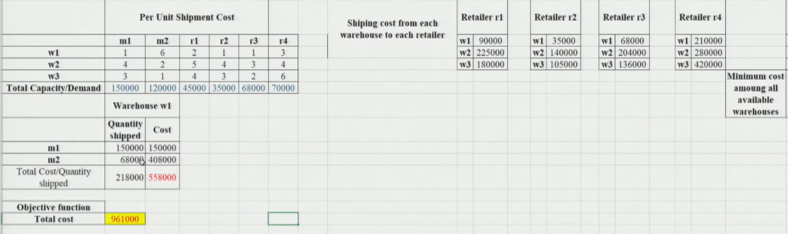
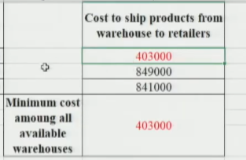
Result — Heuristic 1
- Flow: M1 → W1 → R1, R2, R3 (and partial R4) | M2 → W1 → R4 (balance)
- Total Cost = ₹9,61,000

5. Heuristic 2 — Cheapest End-to-End Path per Retailer
Logic
- For each retailer individually, evaluate all possible paths: every Manufacturer × Warehouse combination
- Select the path (M → W → Retailer) with the minimum total cost
- Apply capacity constraints after selecting paths
- For each retailer, choose the warehouse where the total delivery cost to and from the warehouse are the lowest.
Paths Evaluated per Retailer
- Each retailer has 6 possible paths (2 manufacturers × 3 warehouses)
- M1 → W1 → Rj, M1 → W2 → Rj, M1 → W3 → Rj
- M2 → W1 → Rj, M2 → W2 → Rj, M2 → W3 → Rj
- Minimum cost path is chosen for each retailer

Applying to the Case
- R1: M1 → W1 → R1 = minimum ✓
- R2: M1 → W1 → R2 = minimum ✓
- R3: M1 → W1 → R3 = minimum ✓
- R4: Tie between M1→W1→R4 and M2→W2→R4
- M1 capacity already almost exhausted (1,48,000 used for R1+R2+R3)
- Remaining 2,000 from M1 → W1 → R4
- Balance 68,000 from M2 → W2 → R4
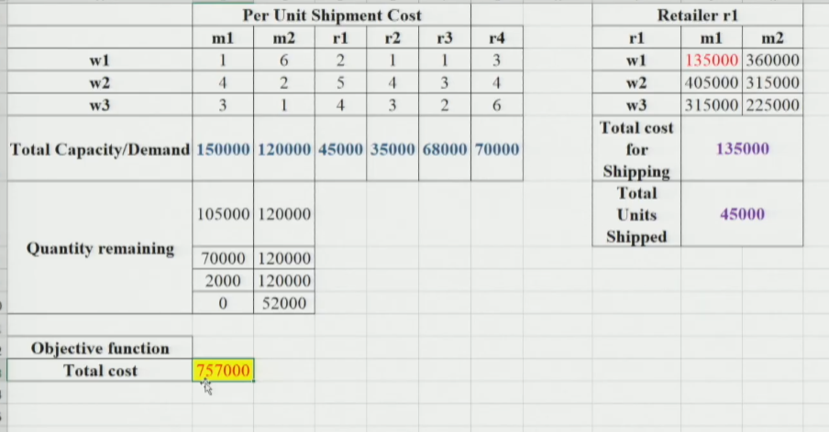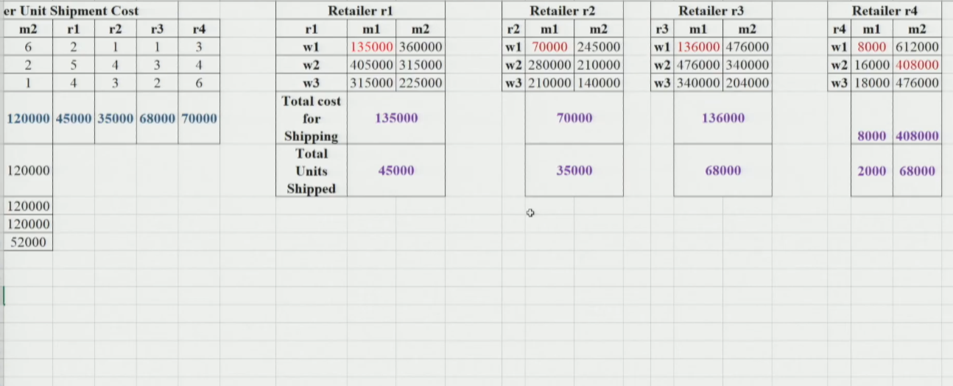
Result — Heuristic 2
- Flow: M1 → W1 → R1, R2, R3 (full) + partial R4 | M2 → W2 → R4 (balance 68K)
- Key difference from H1: R4 balance goes via W2 (not W1) → lower cost path
- Total Cost = ₹7,57,000 ← better than H1
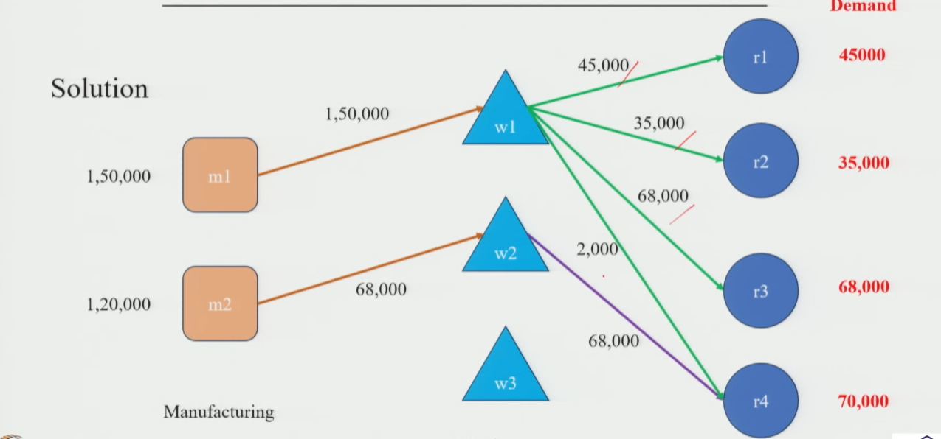
6. Heuristic Comparison & Open Question
 | Heuristic 1 | Heuristic 2 | Optimal (next session)
Logic | Pick cheapest warehouse for all retailers, then cheapest manufacturer | For each retailer: find cheapest end-to-end path (Mfr→WH→Retailer) | LP / solver — guarantees global minimum
Scope | Warehouse-level decision only | Full path evaluation per retailer | All combinations simultaneously
W used | W1 for all retailers | W1 for R1,R2,R3 and W2 for R4 (68K) | TBD
Total Cost | ₹9,61,000 | ₹7,57,000 | ? (≤ ₹7,57,000)

- H2 improved cost by ₹2,04,000 (~21%) over H1 simply by evaluating full paths
- But: is H2 the best possible? We don't know yet
- Next session: solve the same problem using LP / Solver to find the true optimal

★ Heuristics are path-dependent — the order in which you assign demand changes your result. Only LP guarantees the global optimum.

Session Summary
- SC Network Design: 2-tier problem (Mfr → WH → Retailer), single product, minimize total distribution cost
- Constraints: Supply limit at each manufacturer + demand fulfillment at each retailer
- Heuristic 1: Pick cheapest WH for all retailers → assign cheapest Mfr first → Cost: ₹9,61,000
- Heuristic 2: Evaluate full end-to-end path per retailer → pick min cost path → Cost: ₹7,57,000
- Key insight: H2 beats H1 because it considers the full Mfr→WH→Retailer path, not just the WH→Retailer leg
- Open question: Is ₹7,57,000 optimal? → answered in next session via LP Solver

★ Exam Tip: H1 logic = cheapest warehouse globally. H2 logic = cheapest path per retailer. H2 is always ≤ H1 in cost (considers more information).
★ Exam Tip: In H2, evaluate all 6 paths per retailer (2 Mfr × 3 WH). Apply capacity constraint AFTER selecting paths — do not ignore it.
★ Exam Tip: Heuristics are feasible but not necessarily optimal. LP/Solver gives the true minimum — always compare.

